Standard Operation Procedure for Garmin Instinct and Garmin Basecamp for GPS operation and data extraction in Spotted Handfish georeferenced UVC survey

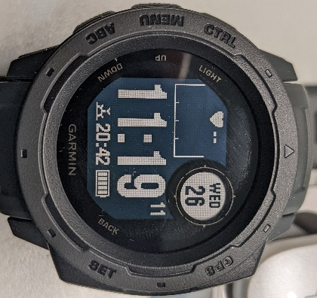Version 2.0 – the Garmin update

Description:

Software specific for the GPS logger from Holux are no longer supported (Jan 2022). Modification to existing SOP required to incorporate new GPS logger and software.

***Drafted by:*** Lincoln Wong-25th Jan 2022

Main screen

1.0 Preparation

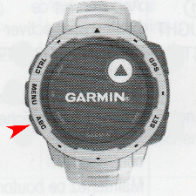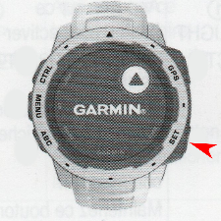1.1 Heart Rate Monitor – toggle

**2**

**1**

The Garmin Instinct included a heart rate (HR) monitor for fitness tracking. It is best to disable this function to preserve battery life. To toggle HR Monitor setting:

1. 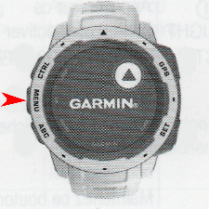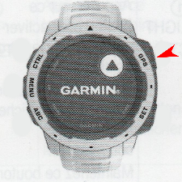Return to main screen by repeatedly pressing the ***Back/set*** key

**3**

**4**

1. Press ***ABC/Down*** key to scroll down to the HR screen
2. Press and hold ***Menu/Up*** key to access the setting menu
3. Navigate to the Heart Rate Options option (first entry) and press ***GPS*** key
4. A close-up of a speaker

   Description automatically generated with low confidence Press ***GPS*** key until Status is toggled to the off position

**5**

**6**

1. Press **Back/set** key repeatedly to return to the main screen

1.2 Data recording type

The Garmin Instinct offer two type of GPS sampling regimes – smart and every second, a trade-off between battery life and track resolution

1. 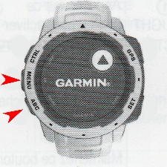A close-up of a speaker

   Description automatically generated with low confidencePress and hold ***Menu/Up*** on main screen to access the setting menu

**1**

1. Navigate to the setting option using ***ABC/Down*** and ***Menu/Up***
2. Press ***GPS*** key to access the setting submenu
3. Navigate to the system option using ***ABC/Down*** and ***Menu/Up***
4. Press ***GPS*** key to access the system submenu

**3,5,7,9**

**2,4,6,8**

1. Navigate to the Data Recording option using ***ABC/Down*** and ***Menu/Up***
2. Press ***GPS*** key to access the Data Recording submenu
3. Select the desire data recording regime with ***ABC/Down*** and ***Menu/Up***
4. A close-up of a speaker

   Description automatically generated with low confidencePress ***GPS*** key to confirm selection

**10**

1. Press ***Back/set*** key repeatedly to return to the main screen

1.3 Potential additional settings

Some basic configurations were required during the initial setup of the device. This section highlighted some of these setting should a factory reset was performed on the device. All setting follows the basic button layout.

1. Navigate to the desired section using the ***ABC/Down*** and ***Menu/Up***
2. Press ***GPS*** key to confirm selection

Initial setups require the user to provide their date of birth, weight and height measurement. For the purpose of this SOP these values can be fictitious.

The initial setup will also require the user to select a unit of measurement. SI units are recommended; however these can be modified in the setting menu after initial setup

The Garmin Instinct will prompt if the user would like to connect it to a device (mobile). It is not required for the operation outlined in this SOP and can be skipped

Before the first GPS tracking activity it is also required to set up the layout for the GPS menu. The user will be prompted to check from a list of activities profiles (The intended purpose will be for the user to highlight sport/activities which they partake in normally). As these profiles will not be used for this SOP, it is recommended to only check one to minimise clutter in the layout view.

Marking activities as favorited-*you can also mark an activity profile as favorited (which I believe will put it at the top of the list). I have done it for the Track me(the one we need) function but I can’t remember the process to do so*



**5**

**3**

**2**

**1**

2.0 Field operation and setting up for record

2.1 Initiating tracking function

1. A picture containing text

   Description automatically generatedOn the main screen, press the ***GPS*** key
2. A picture containing text

   Description automatically generatedNavigate to the Track Me option using ***ABC/Down*** and ***Menu/Up***
3. Press ***GPS*** to confirm selection
4. Standby for device to acquire GPS connection (Indicated by circle screen located top right)
5. Press ***GPS*** to begin recording track

2.2 Pausing and saving track

**1**

**3**

**4**

1. On completion of track, press the ***GPS*** key to pause record
2. Wait for selection menu to appear (about 2-3 seconds)
3. Navigate to the Save option using ***ABC/Down*** and ***Menu/Up***
4. Press ***GPS*** to confirm save order

3.0 Extracting track to Garmin Basecamp

Testing